Hi Guys, Hope you’re all doing great.
Above video shows Image Classification task accomplished using Convolutional Neural Network. In this post, I’ll be going through the entire process I have adopted to accomplish task.
Goal
The Goal is to classify images among the following 5 categories:
- Indoor
- Outdoor
- Night
- Day
- Landscape
User is supposed to select a category to display all related images.
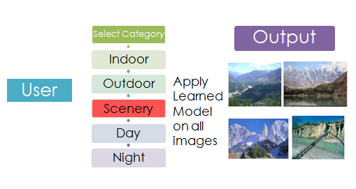
Dataset
For each of the 5 categories, I collected the images from Google Search. These are the number of images I collected, and labels for each category. The total dataset comprised around 8000 images.
Class | Label | No of Images
Indoor | 0 | 2200
Outdoor | 1 | 2476
Night | 2 | 1143
Day | 3 | 1689
Landscape | 4 | 588

Transfer Learning
The classifier used is Convolutional Neural Network. I have used VGG Places CNN to extract features from Images. Here is the architecture of this Network.
Layer | Dimension
Data (input) | 50,3,224,224
conv1_1 | 50,64,224,224
conv1_2 | 50,64,224,224
pool1 | 50,64,112,112
conv2_1 | 50,128,112,112
conv2_2 | 50,128,112,112
pool2 | 50,128,56,56
conv3_1 | 50,256,56,56
conv3_2 | 50,256,56,56
conv3_3 | 50,256,56,56
pool3 | 50,256,28,28
conv4_1 | 50,512,28,28
conv4_2 | 50,512,28,28
conv4_3 | 50,512,28,28
pool4 | 50,512,14,14
conv5_1 | 50,512,14,14
conv5_2 | 50,512,14,14
conv5_3 | 50,512,14,14
pool5 | 50,512,7,7
fc6 | 50,4096
fc7 | 50,4096

I have plugged a Softmax classifier as the last layer in the above network. This layer takes in fc7 Features from the previous layer and outputs five probabilities corresponding each category.
- Training
The last layer comprising Softmax Classifier is trained on 70% of the dataset. The remaining 30% is used for testing purpose.
- Testing
87.5% Images are correctly classified among the test set. Following is the confusion matrix for classifications on the test set.
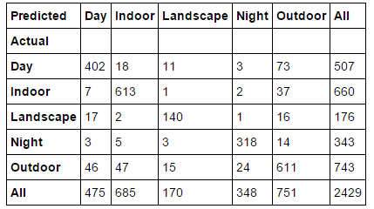

To see how the classifier is performing on unseen data, here is a video showing the classification on unseen images neither part of test or train set.

